# BLG 517E Modelling and Performance Analysis of Networks

## Project Proposal: Commanding UAVs Using Redundant Communication System

The project is about sending command packets to UAV nodes safely. UAV operators will send commands continuously and command packets must go to the UAV using the most available path in the network.

There will be cases which involves some stations or computers to slowdown or shut down completely, the system should decide which computer or station to use in order to transmit the packet to the UAV.

The performance analysis will be done based on the measurement of delay for command packets. The number of hops is also important because there can be a situation that the link between a station and the UAV can be lost. For this case, computers and stations will have links that connect each other for redundancy of communication.

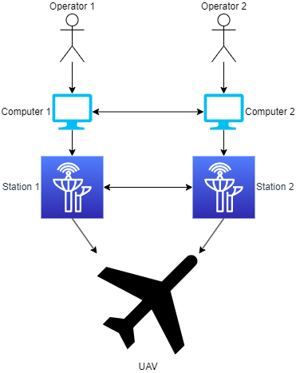

Figure 1. An example communication network

An example system is given above. Computers, stations and the UAV will be the communicating nodes in the system. The aim will be to simulate the slowdown or failure of nodes and analyze the performance of the system.